What is EXIF, IPTC and XMP metadata
Posted on
EXIF (Exchangeable Image File) is a format embedded into images produces by all digital cameras. EXIF data contains all information about the setting used to take an image. When you capture a digital image the camera automatically records all information it knows about this image and saves it as EXIF data. This is done regardless of which shooting mode you are in, whether it is Auto, Manual or anything in between. EXIF information includes camera make and model, date, shutter speed, aperture settings, ISO setting, focal length at which the image was shot and much more. Some cameras and smart phones that have GPS receiver can even record exact position at which the photo was captured (if GPS function is enabled). When images are saved to computer all this data is transferred as a part of an image.
IPTC (International Press Telecommunications Council) is a format originally adopted by old media news agencies to streamline information but it has been later implemented by the new media to pretty much do the same thing. IPTC section of an image usually contains lots of information about the image, such as Title, Description, Keywords, Photographer’s information, Copyright restrictions and much more. Nowadays most stock agencies, imaging software and even search engines use this information for sorting, accurate searching results and copyright information.
XMP (Extensible Metadata Platform) is a recently adopted format created by Adobe. It essentially incorporates all the information from IPTC format and allows for additional information to be stored within an image.

How is EXIF metadata useful?
EXIF data is an extremely useful tool for learning about photography. If you wanted to experiment and practice different photo settings, it would be very difficult and time consuming to record all of the parameters you’ve used throughout the shoot by hand. EXIF data is a format that does it automatically. When checking EXIF data you can see exactly which settings have been used on each photo and see how different parameters affect your photos. You can even go back to your old photos and check which settings were used.
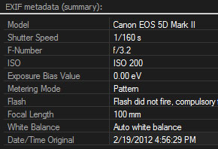
EXIF metadata in ACDSee Pro 4
Similarly you can also check other photographer’s work and see which settings were used to take the shot. When you start doing it, however, you may notice that EXIF data might be missing. This can happen for several reasons. Image editing software can erase this data on different saving options or the photographer may intentionally strip down this data in fear of exposing his/her techniques. Nonetheless, many photographs have available EXIF data either because a photographer doesn’t know it exists or he/she wants to demonstrate image setting for other people to analyze and learn from. Many photo sharing sites employ EXIF data to show these setting. Sometimes they use different terms for it like image information or properties.
EXIF data can also be useful when asking for constructive criticism for your photos. You can provide this data so other photographers can analyze your settings and offer useful feedback on how you can improve your shots.

How is IPTC and XMP metadata useful?
IPTC metadata can be useful for copyright protection. Many digital cameras will let you set a copyright name to be saved with all your photos in IPTC data. Moreover you can manually add your copyright notice to your photos in IPTC format on a computer. This can be very beneficial for protecting your images from being used illegally (unless this data is intentionally erased).
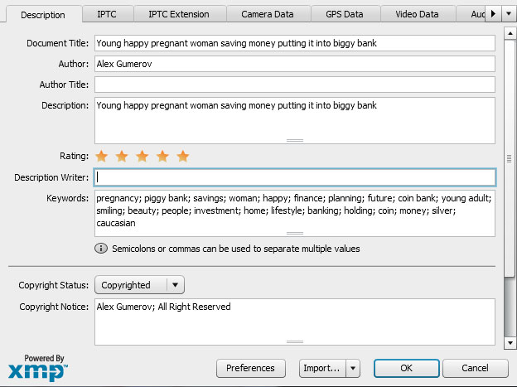
File Info window in Adobe Photoshop CS6
IPTC metadata can also be very useful when searching through a large database of images. IPTC data allows you to add title, description and keywords to your images. Any search looks at all of these parameters to find your requests. So if you have a huge database of images it might be useful to get into habit of assigning these parameters to your images for easier access. This can also be useful to your clients if you sell your digital images. Additionally, most stock agencies use IPTC format. If you are selling your work as stock, always use IPTC metadata to give description and keywords to your images. This can really speed up your submission process.

How to see and edit EXIF and IPTC metadata
There are several ways you can view EXIF data and some of them will even let you edit several parameters.
- Camera: The first place where you can check your image settings is right on your camera. Most digital cameras will let you check many photo settings on LCD screen. They do it by referring to image’s EXIF data. This can usually be achieved by pressing camera’s “Info” button but it may vary on different cameras.
- Computer: Computer operating system typically has a pre build functionality that can show a lot of EXIF IPTC data. On PC you can right-click on an image, select “Properties” then hit “Details” tab (Vista/Win7) or “Summary” tab then “Advanced” button (Win XP). On a Mac you can find basic EXIF information by selecting “Get Info” on a file and selecting “More Info” section.
- Post-Processing and viewing Software: Most advanced image processing programs have a method for viewing file’s EXIF data. These include Adobe products and viewing programs such as iPhoto or ACDSee. In Adobe Photoshop, you can view this info by selecting “File” and pressing “File Info…” option. Unlike many other programs Adobe Photoshop’s EXIF information can even display the exact lens used for a particular image which can be very useful when analyzing different lens qualities. In Adobe Lightroom, EXIF data can be viewed in the Library Module under the Metadata panel. Software such as iPhoto, Lightroom, ACDSee and even some online photo sharing sites can even show a map with pins where each photo was taken based on EXIF data (available only on GPS enabled cameras).
- Internet Browsers: Most browsers have available plug-ins or extensions which can allow you to view file’s EXIF information just by right-clicking on it, although you may see a lot of images missing its metadata info online. This can happen for a couple of reasons. When images are optimized for web their EXIF data is often erased. Also some photographers choose to strip down their EXIF information to maintain “trade secrets.”
Some programs will also let you add and edit IPTC metadata. In Adobe Lightroom you can apply IPTC information to the entire patch of images during import. Just use “Apply During Import” setting and preset exactly what exactly needs to be applied. It can be anything from keywords to copyright information. Programs such as ACDSee, Photoshop, Bridge, iPhoto, Aperture and many others will let you add and edit IPTC metadata.

Some Considerations
There are several considerations you should take into account regarding EXIF data. When the date is set incorrectly on your camera, it will be preserved on all of your images. You may go back to your photos and think they are shot at one date while they were shot during a completely different time. Therefore it is important to always have your camera’s date and time set correctly.
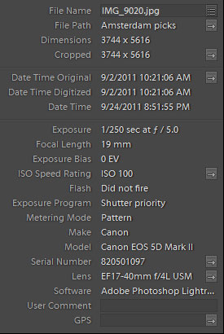
EXIF metadata in Adobe Lightroom 4
Another important issue related to EXIF data is GPS coordinates and privacy. Many people are not even aware of this. When taking photos with a GPS enabled camera or smart phone these coordinates are saved into EXIF data (unless it is manually disabled). When these photos are published online anybody can check EXIF information and see the exact location where the image was captured. While this can be beneficial in many situations, sometimes this can become a serious violation of privacy. In a case, for example, where the image was taken at your home, location of which you don’t want most people to know.
Finally there have also been some instances where editing metadata using one program may limit another’s programs ability to read it correctly. However, this is very rare.
This entry was posted by Alex Gumerov.
MyPhoto Central
http://www.myphotocentral.com/articles/exif-iptc-xmp-metadata/

